MEHRAN UNIVERSITY

OF ENGINEERING & TECHNOLOGY

JAMSHORO, PAKISTAN

To configure the RIP dynamic routing protocol on two routers

Subject: COMPUTER NETWORKS (PR)

(Lab 9 - Tasks Solution)

|  |  |
| --- | --- |
| **Roll No:** | **22SW028** |
| **Section:** | **I** |

**LAB TASKS:**

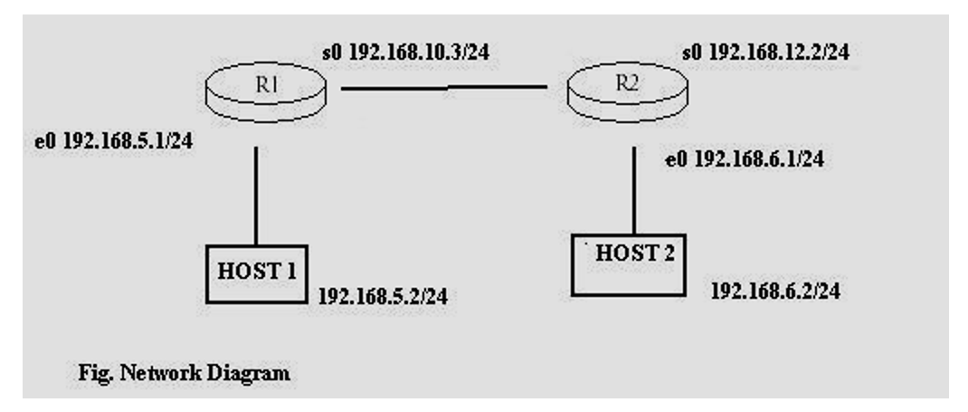

Note: The serial connection on router 2 should be 192.168.10.2 for the network to work.

The network built is:

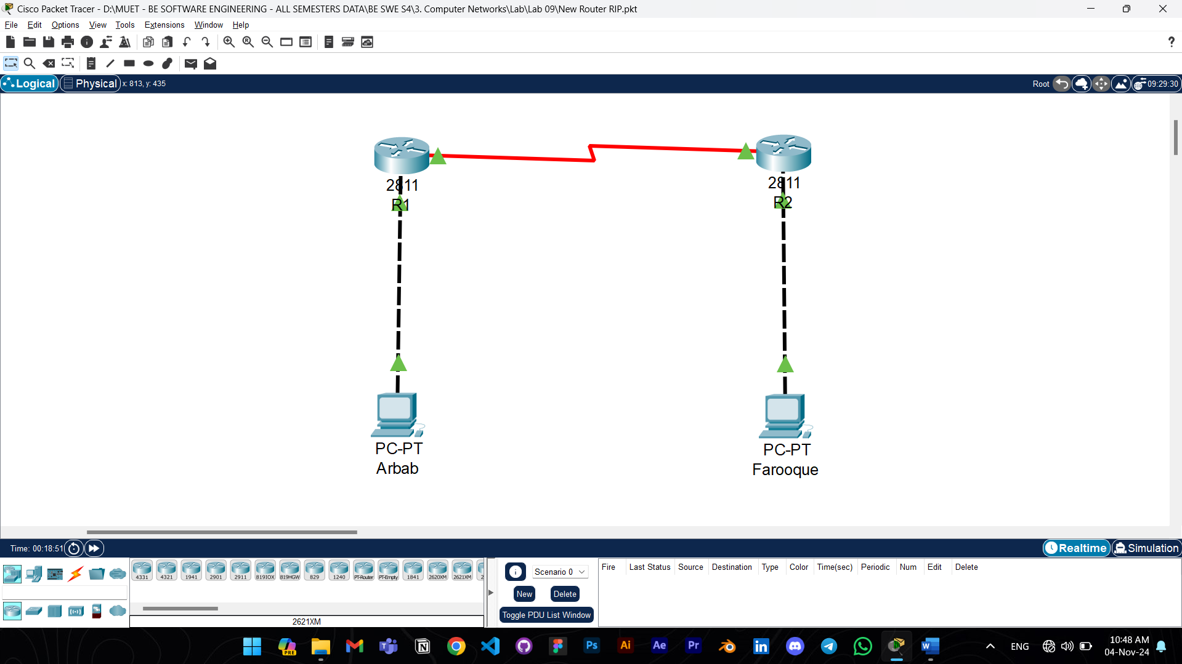

Answers to the questions given in Lab Manuals are below.

**Answers to Questions:**

**Q1. How would you assign a class A IP address to interface Serial0 on Router1?**

Ans: To assign a class A IP address to interface Serial0 on Router1, you could use the following commands:

Router1(config)#int s0

Router1(config-if)#ip address 10.0.0.1 255.0.0.0

Router1(config-if)#no shut

*Here, 10.0.0.1 is a class A IP address, with a subnet mask of 255.0.0.0.*

**2. Are all the necessary interfaces up?**

Ans: Yes, all necessary interfaces on both router 1 and 2 are up.

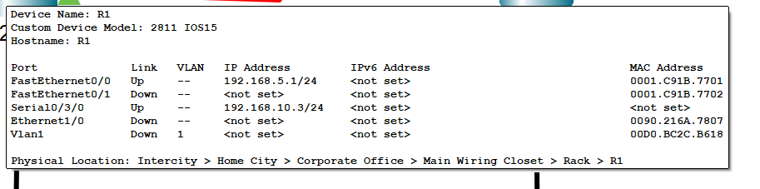

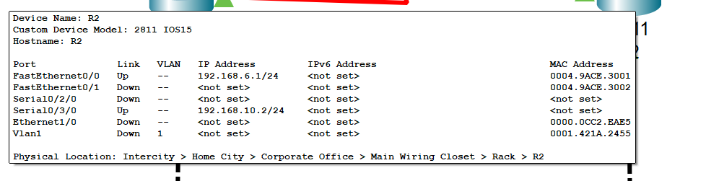

**Q3. What are the entries in the routing table?**

Ans:

R1:

R2:

**4. What is the administrative distance?**

Ans: The administrative distance for RIP is **120**.

Note: The configuration commands aren’t added in the tasks as they are already present in the manual. The packet tracer file of the following task is also attached with the assignment.